Activity 2c

Smart Watch

Rohan Girase

Omkar Salunke

Manoj Dumpa

Kavya Kumar Vallurupalli

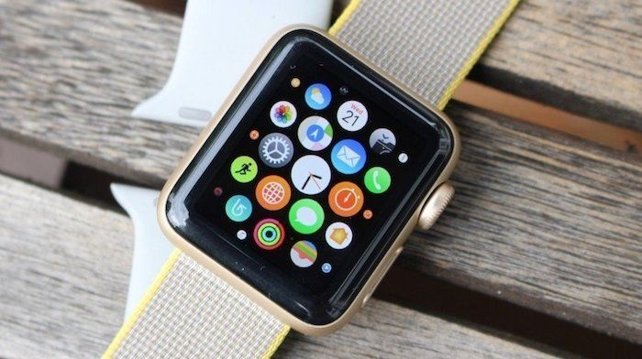

First Impression:

Good

* Both way of watch representation i.e. analog and digital.
* Easy access to mobile notification and calls i.e. making it more compact device
* Tracing fitness activities.
* Changing look and feel easily i.e. more customizable.
* View maps.

Bad

* Overhead of charging another device other than mobile phone.
* Small screen, hard to operate sometimes.

User Experience Goals:

* Satisfying Exp, Enjoyable & Fun: Meets the expectation and performs well under any condition. Listening music, play game, use it as casting device.
* Motivating: Maintains user’s entire health report i.e. heart rates. Workout details and suggest user what more needs to be done.
* Helpful: Accessing calls and notification, viewing map.
* Pleasing: Responsive and well designed interface.
* Creativity Rewarding: Smart watch can be considered as potential replacement of mobile phone.
* Emotionally Fulfilling: Justifies the need for what is designed.

Usability Goals:

* Effectiveness: Potential replacement of a mobile phone.
* Efficiency: Ease of use i.e. touch screen device. Safety features like touch pad for authentication.
* Easy to learn: User can easily use it with minimal manual i.e. easy interface no complex tasks involved.
* Easy to remember: Once user uses it, it gets easy to use henceforth.